**Create an EC2 Instance in the us-east-1 region with the following requirements**

Give the tag name of both EC2 instance & keypair as “ ec2usecase1” (NAME)

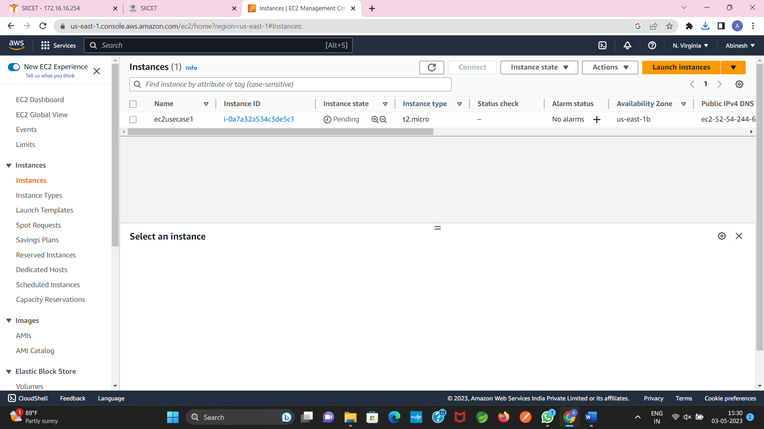

EC2 instance AMI should be “Amazon Linux 2”

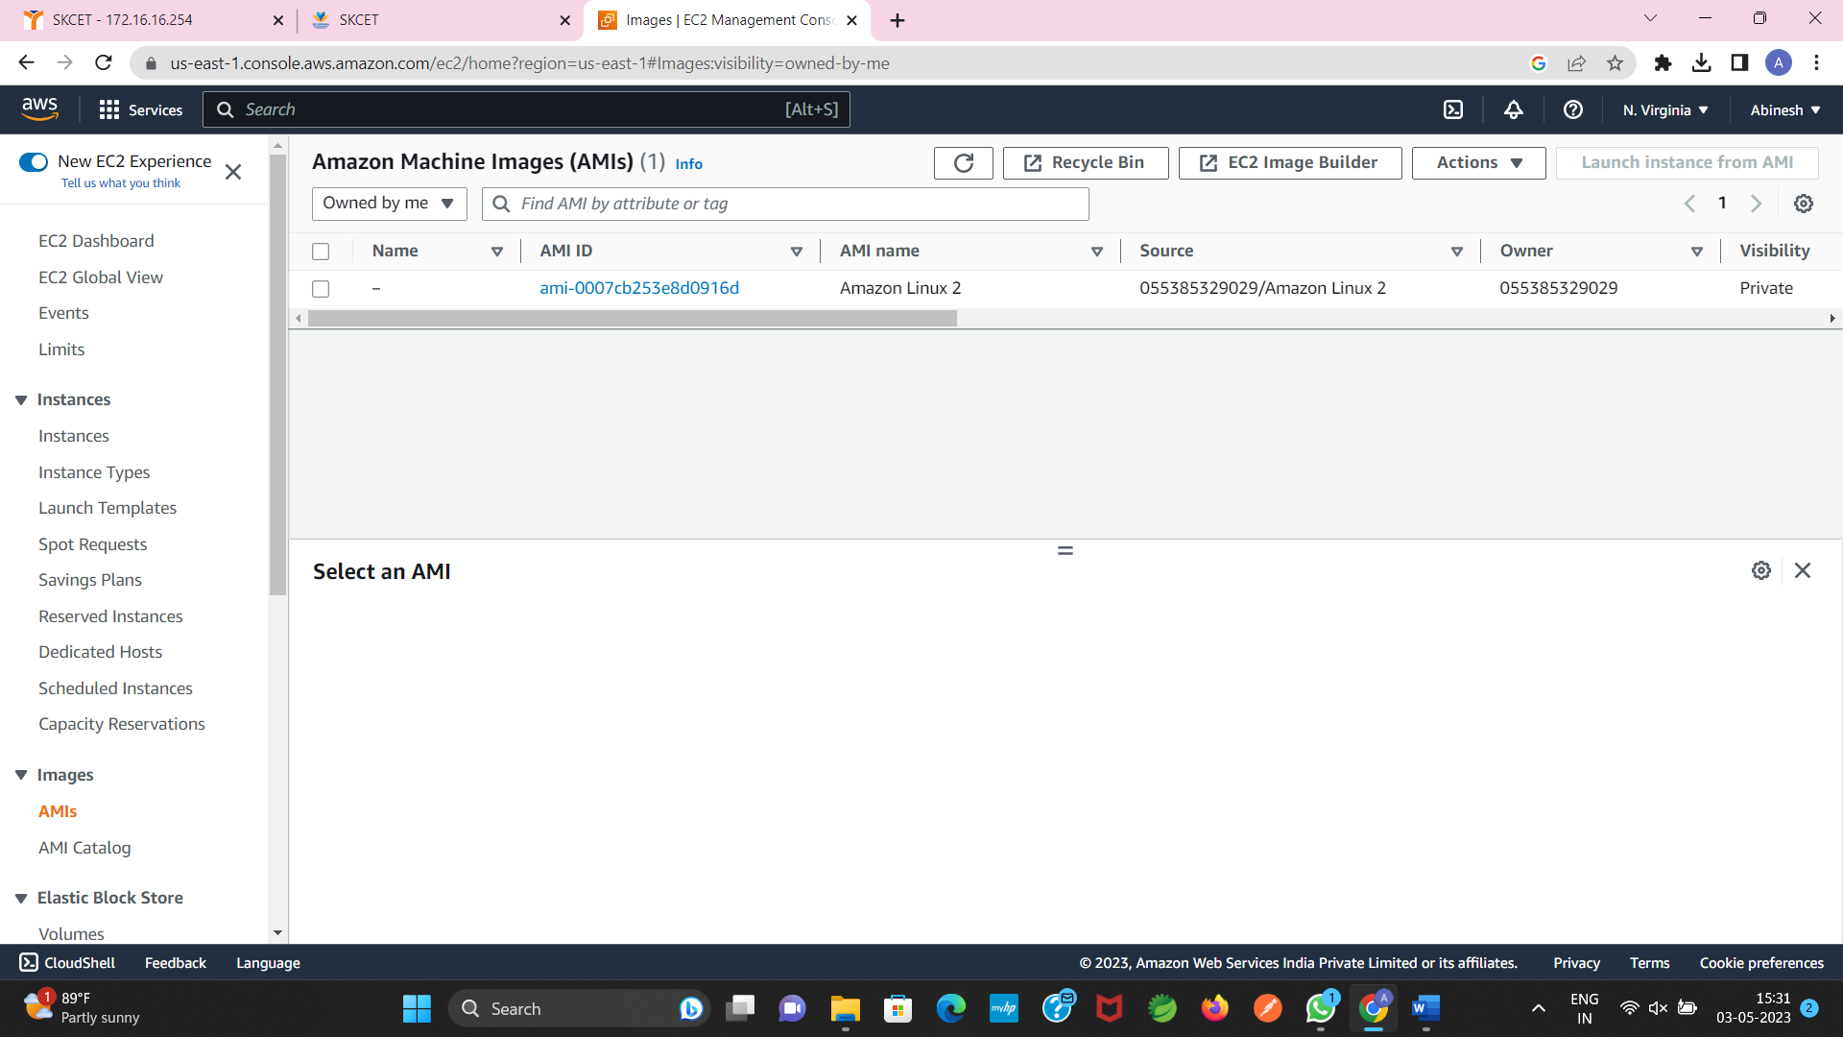

Allow SSH traffic for taking putty remote connection

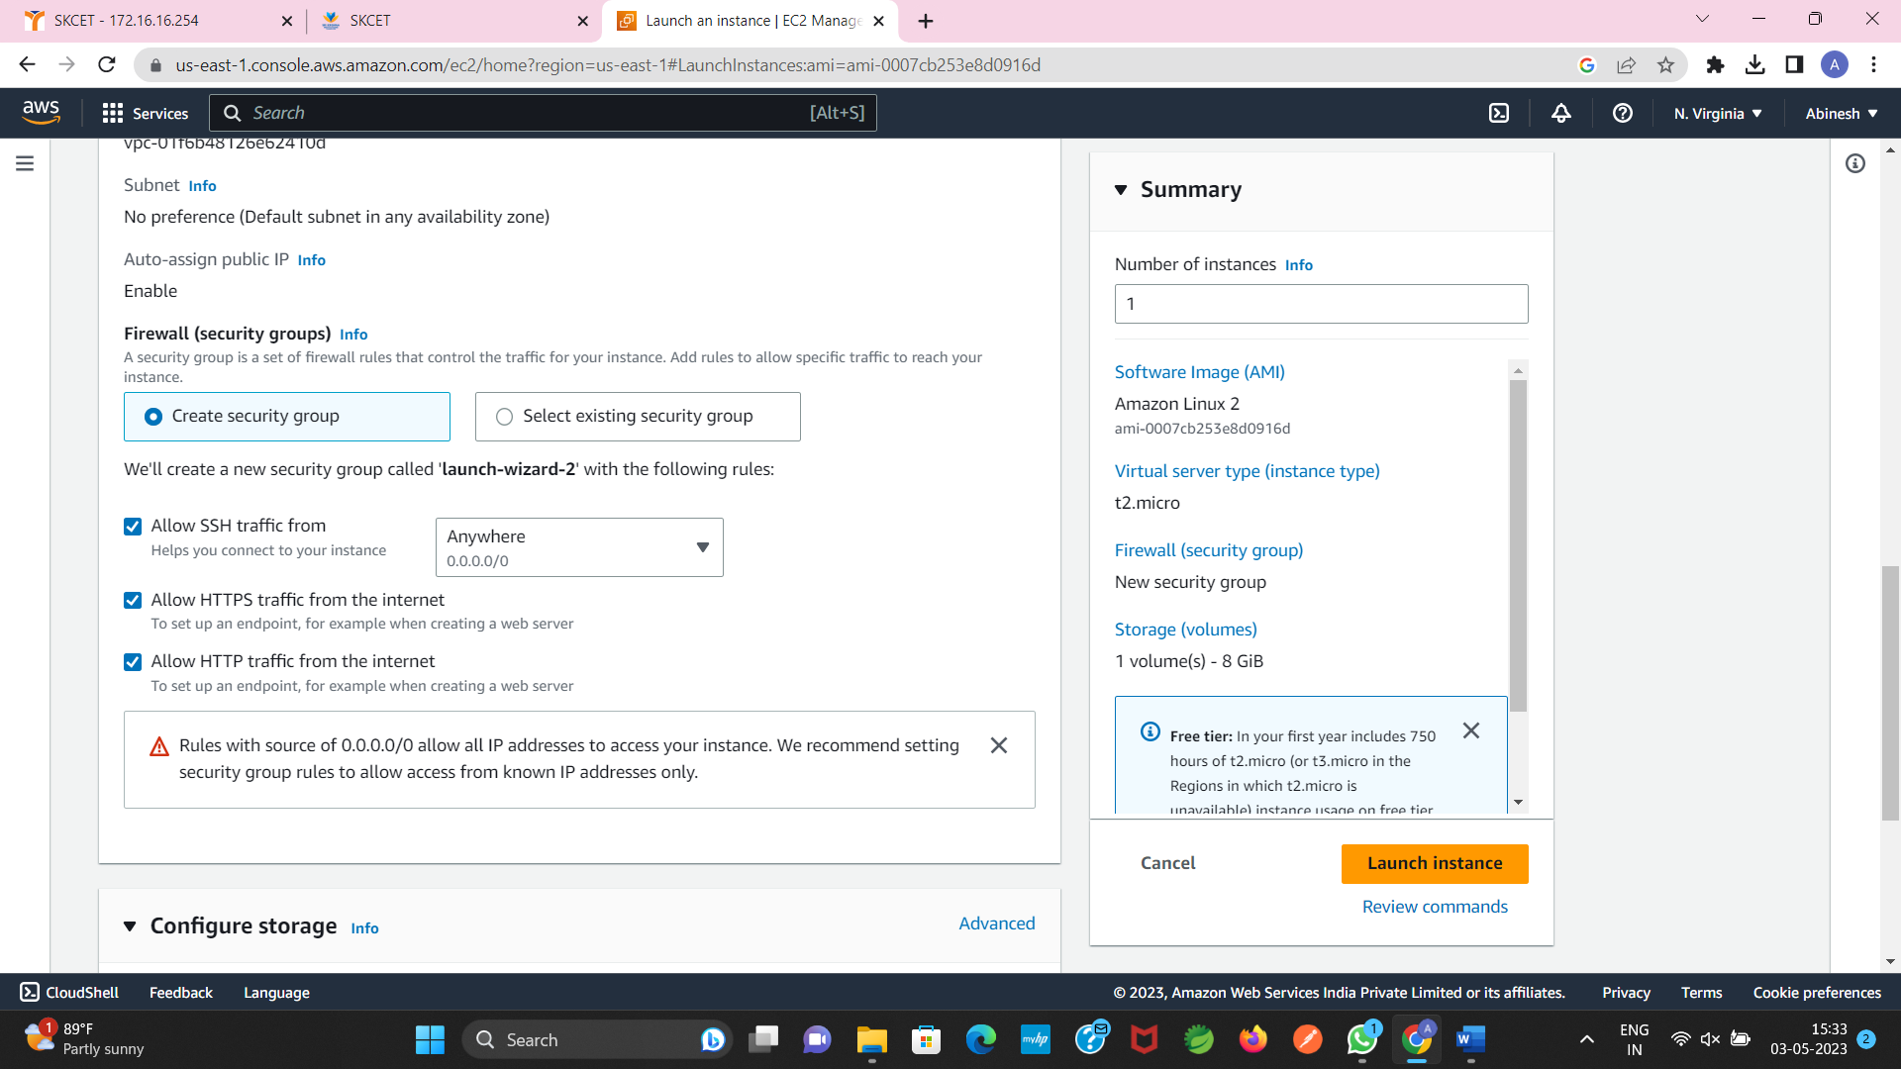

Allow http traffic from the internet for reaching website request



2.

The name of the IAM group should be “Network-L1-Team”

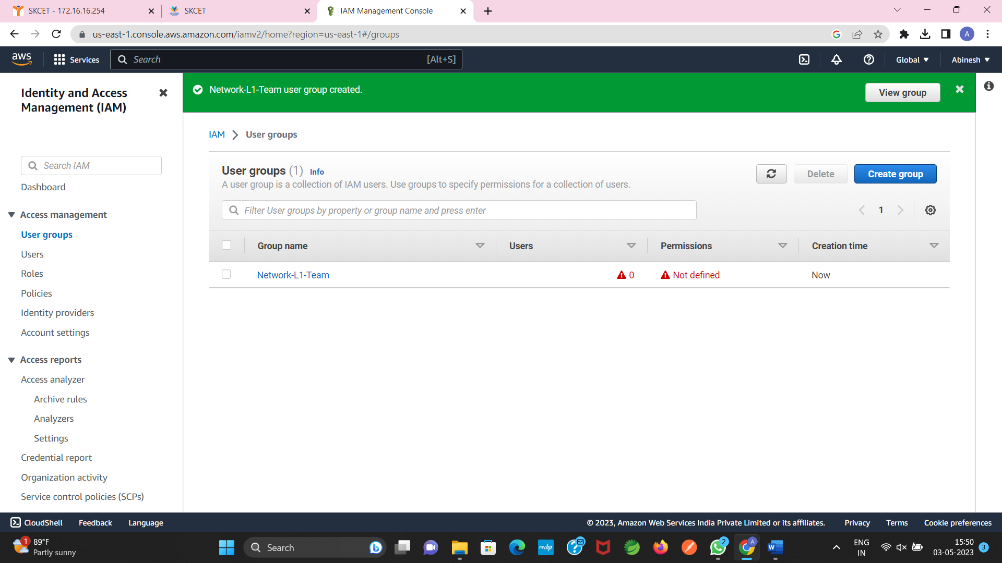

The name of the IAM user should be “Network-L1-User1”

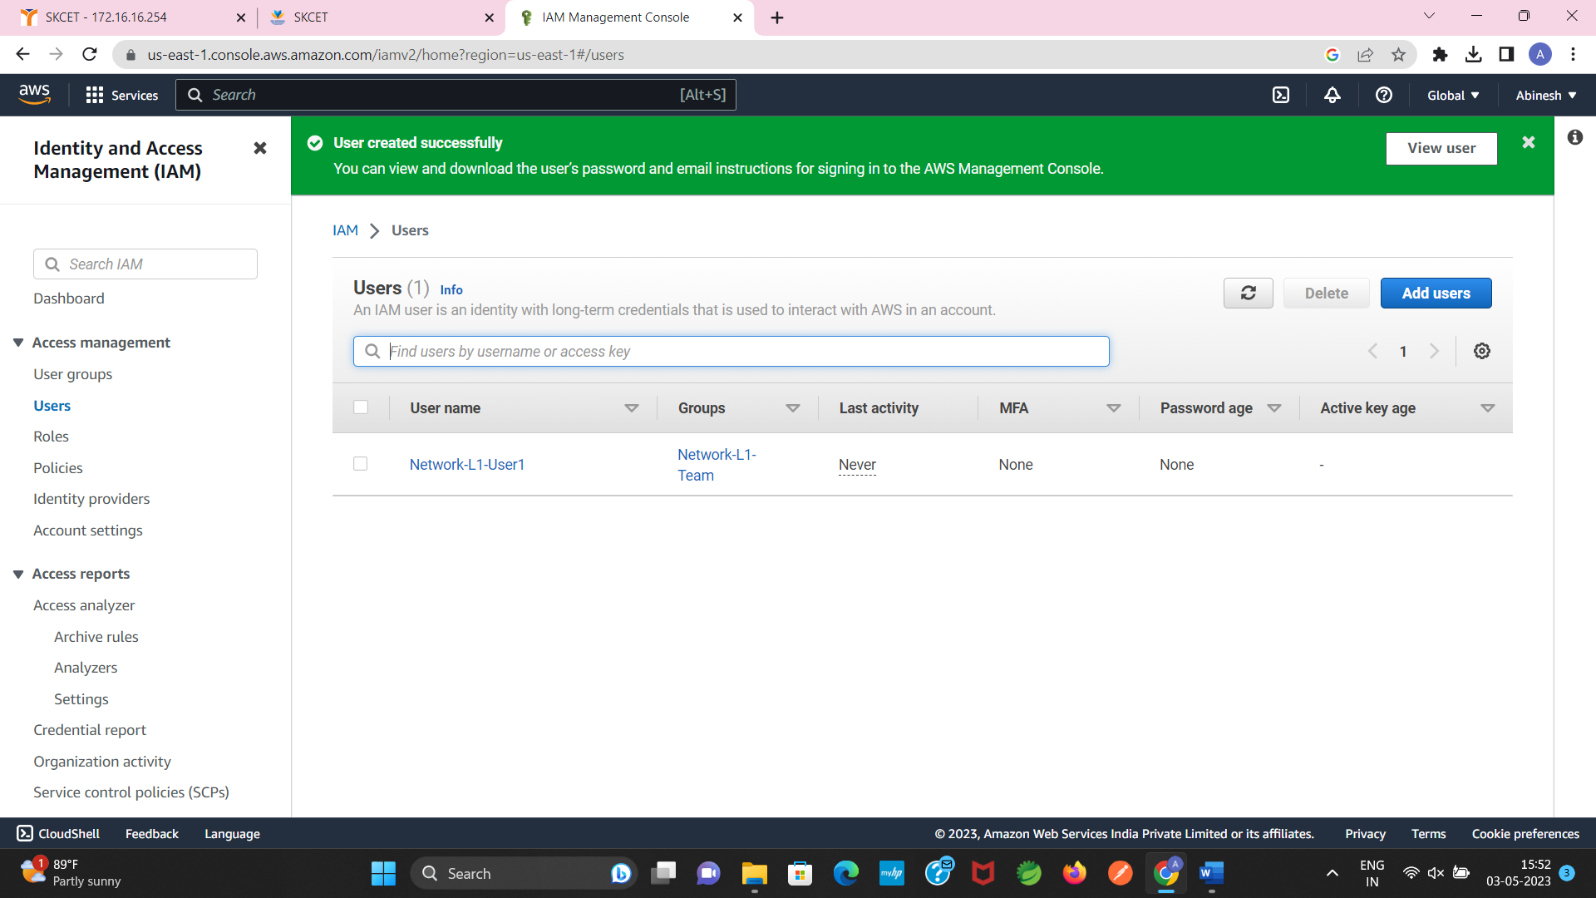

The “AmazonVPCReadOnlyAccess” policy should be attached

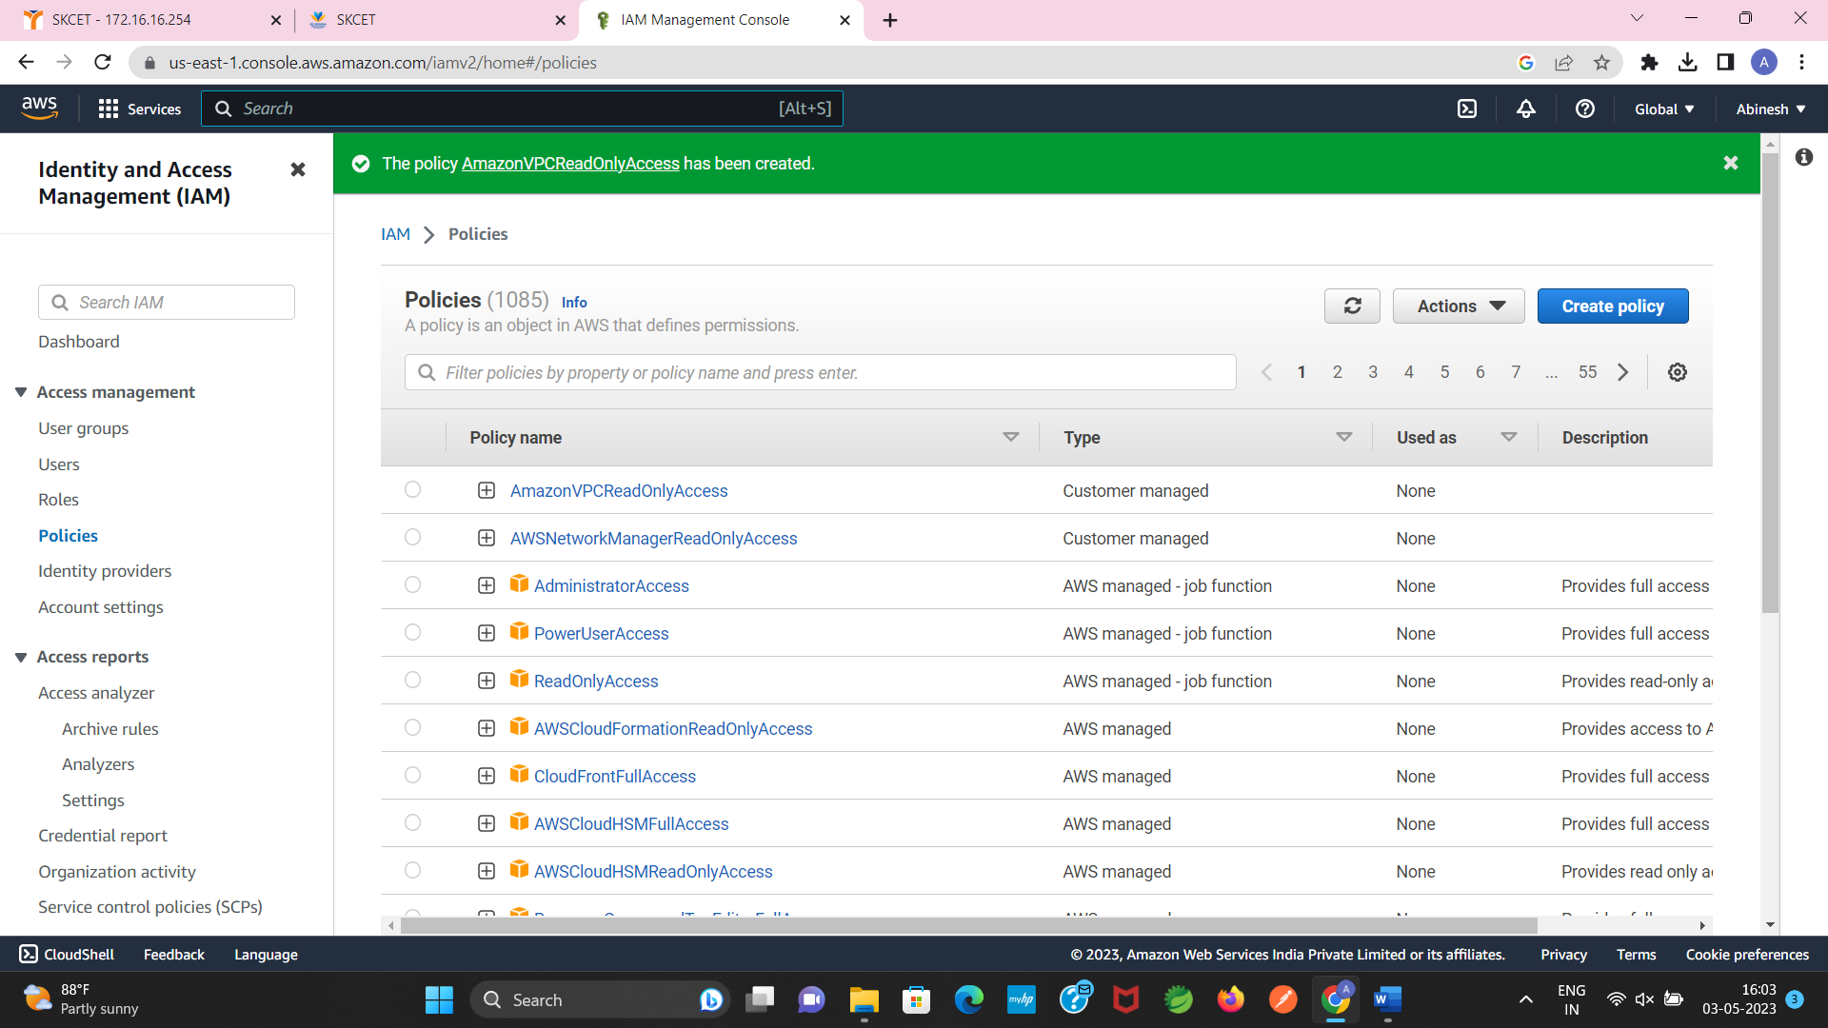

The “AWSNetworkManagerReadOnlyAccess” policy should be attached

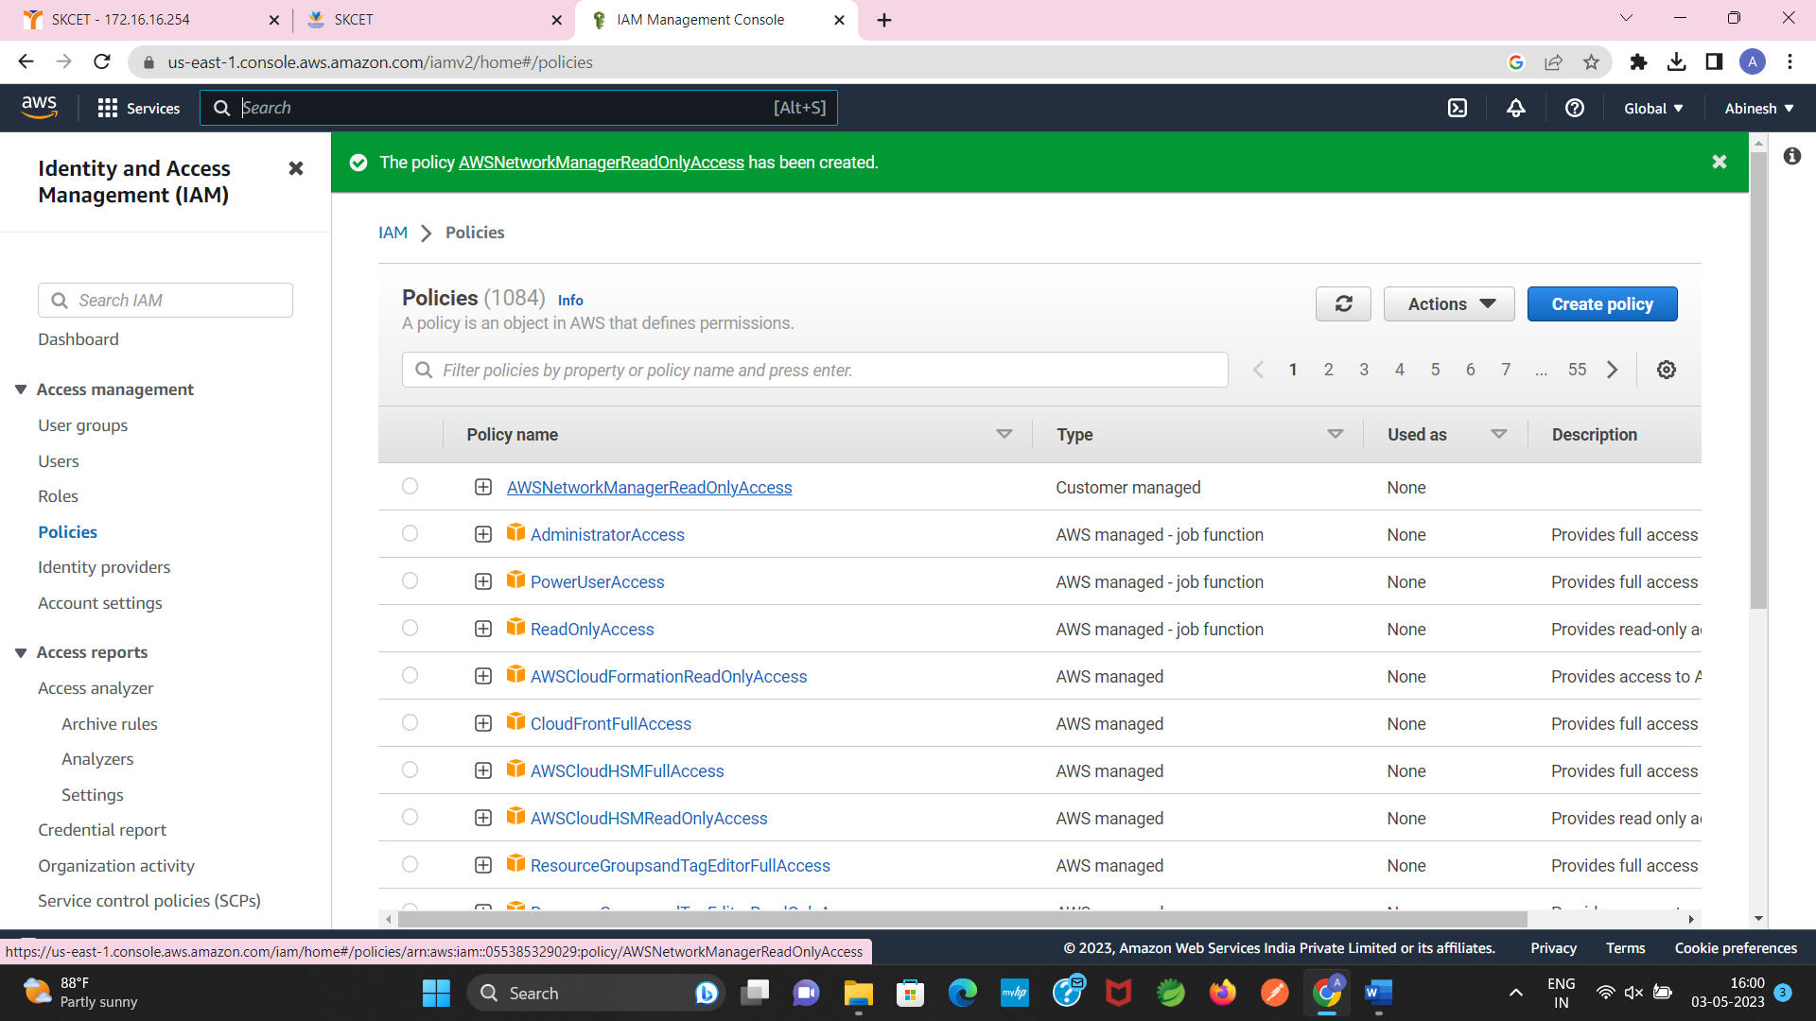

3.

Create new S3 bucket in the region of “Stockholm”

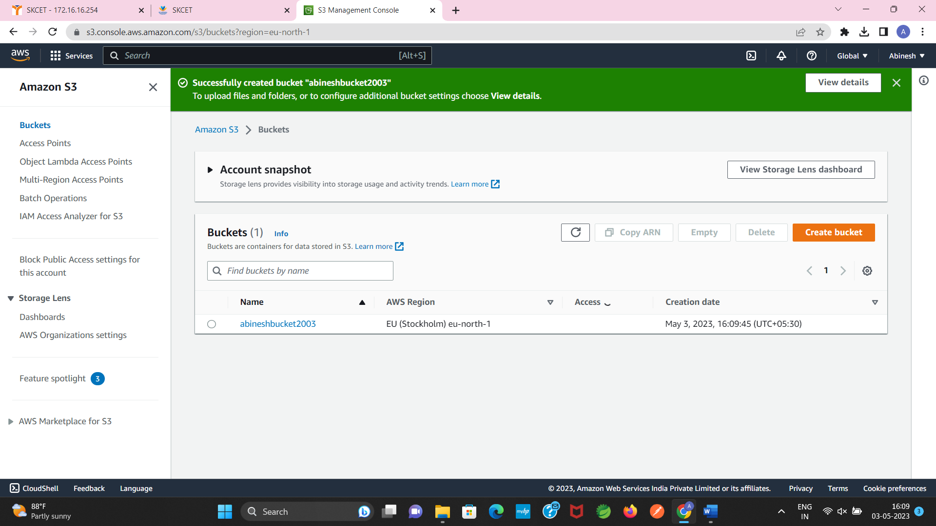

Make the bucket Accesible to everyone(publicly) via Bucket ACL

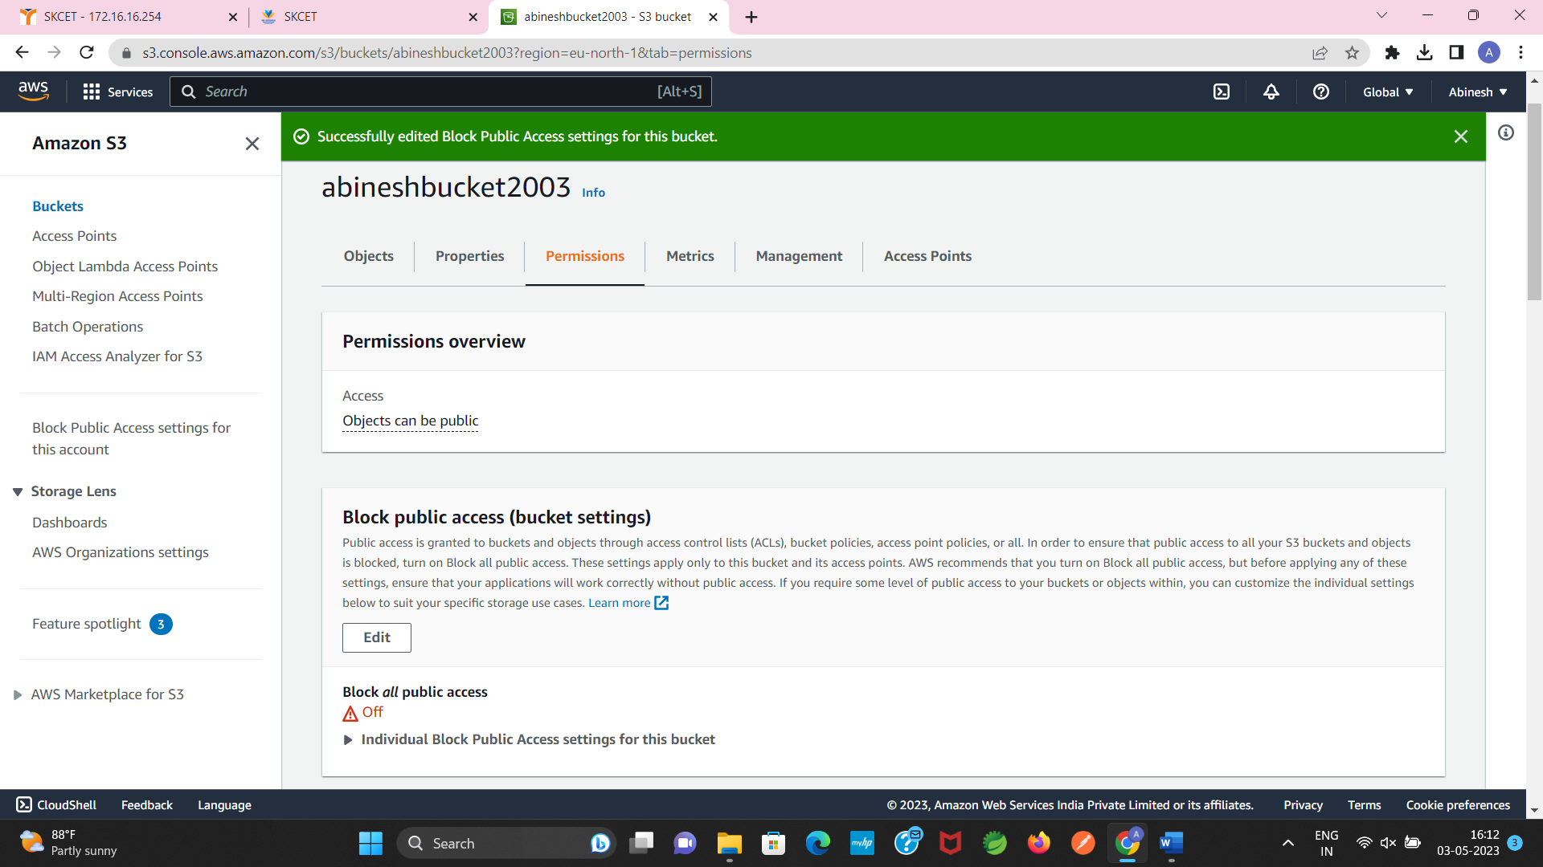

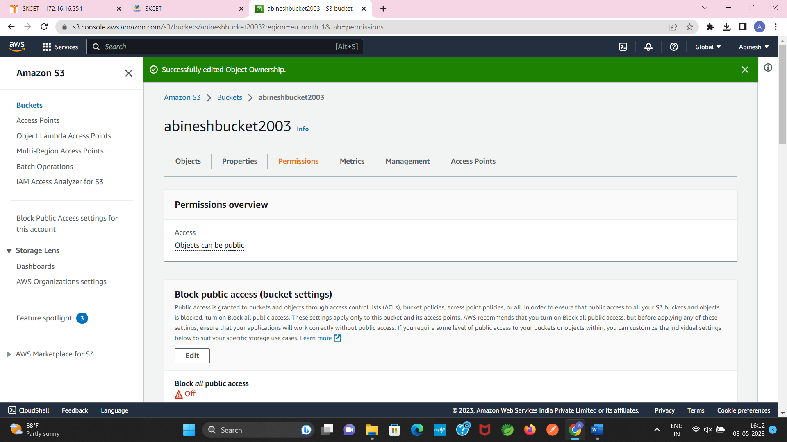

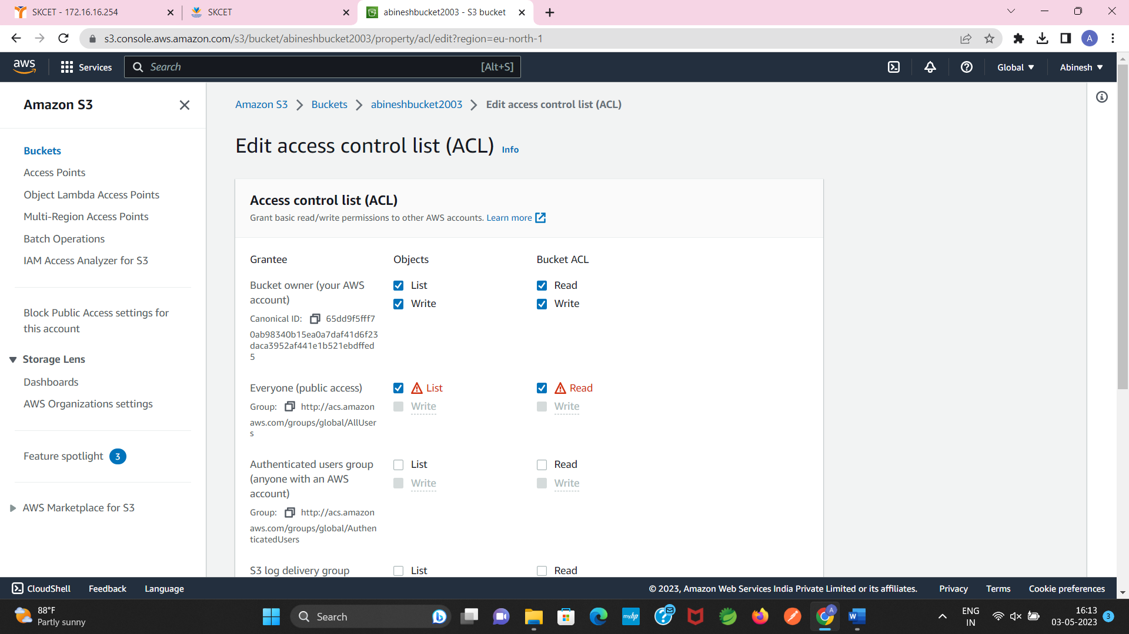

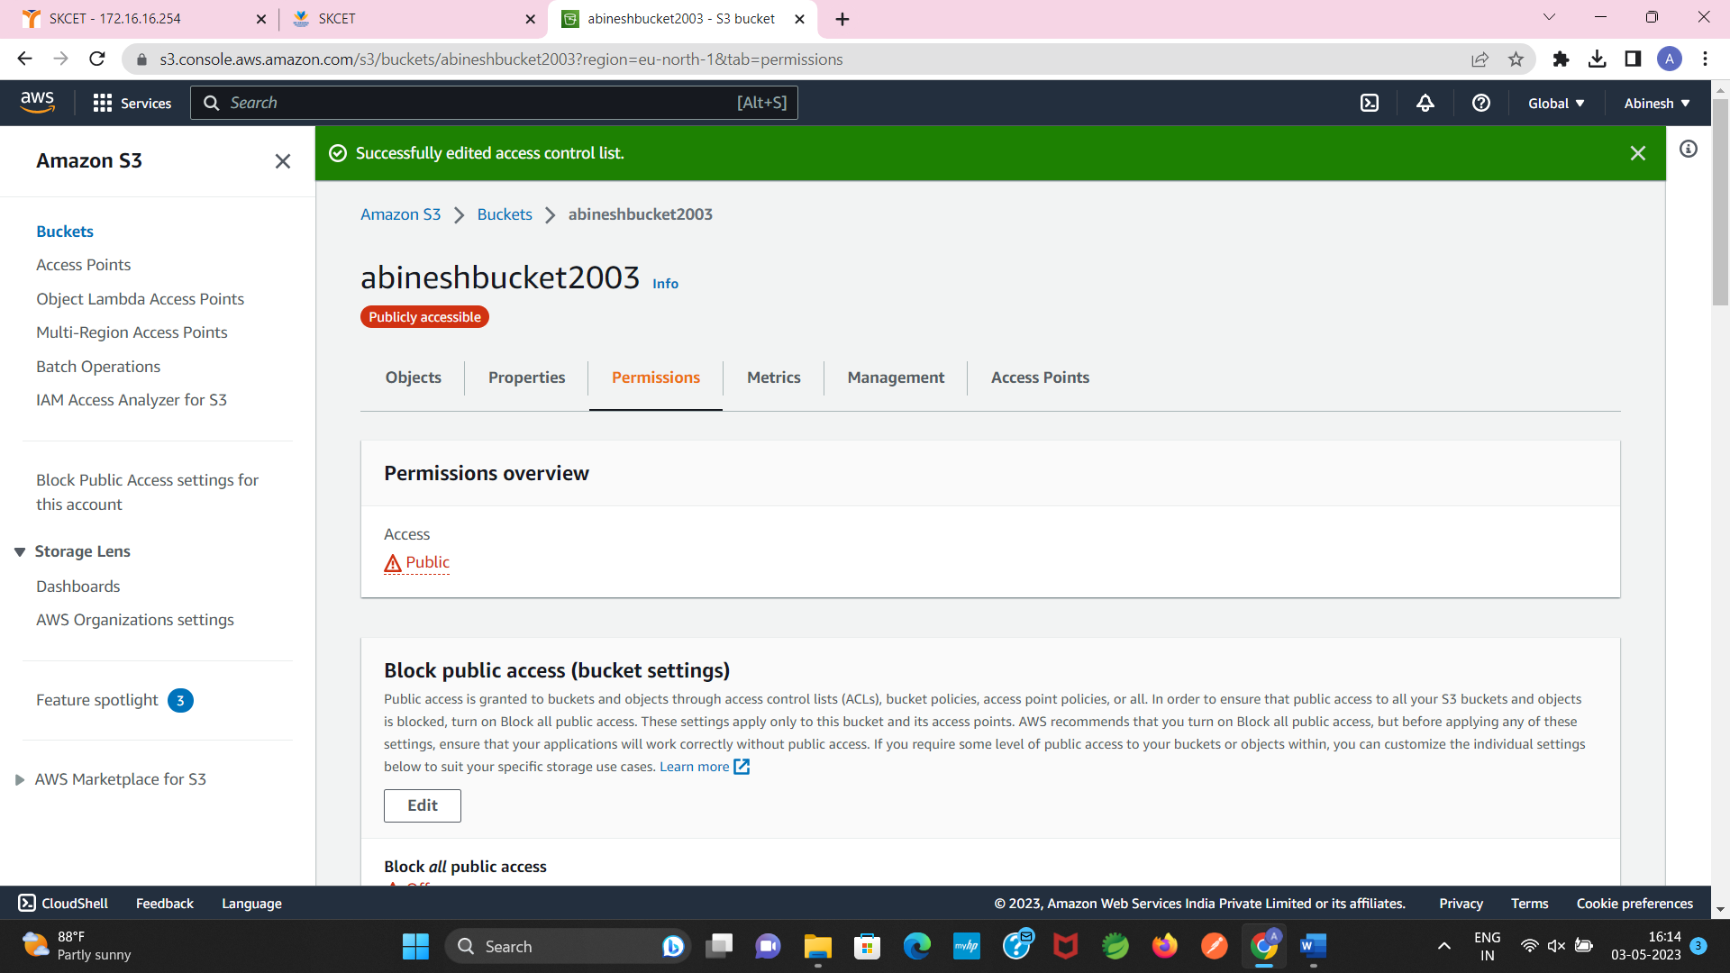

Upload the text file in the name of “accounts.txt”

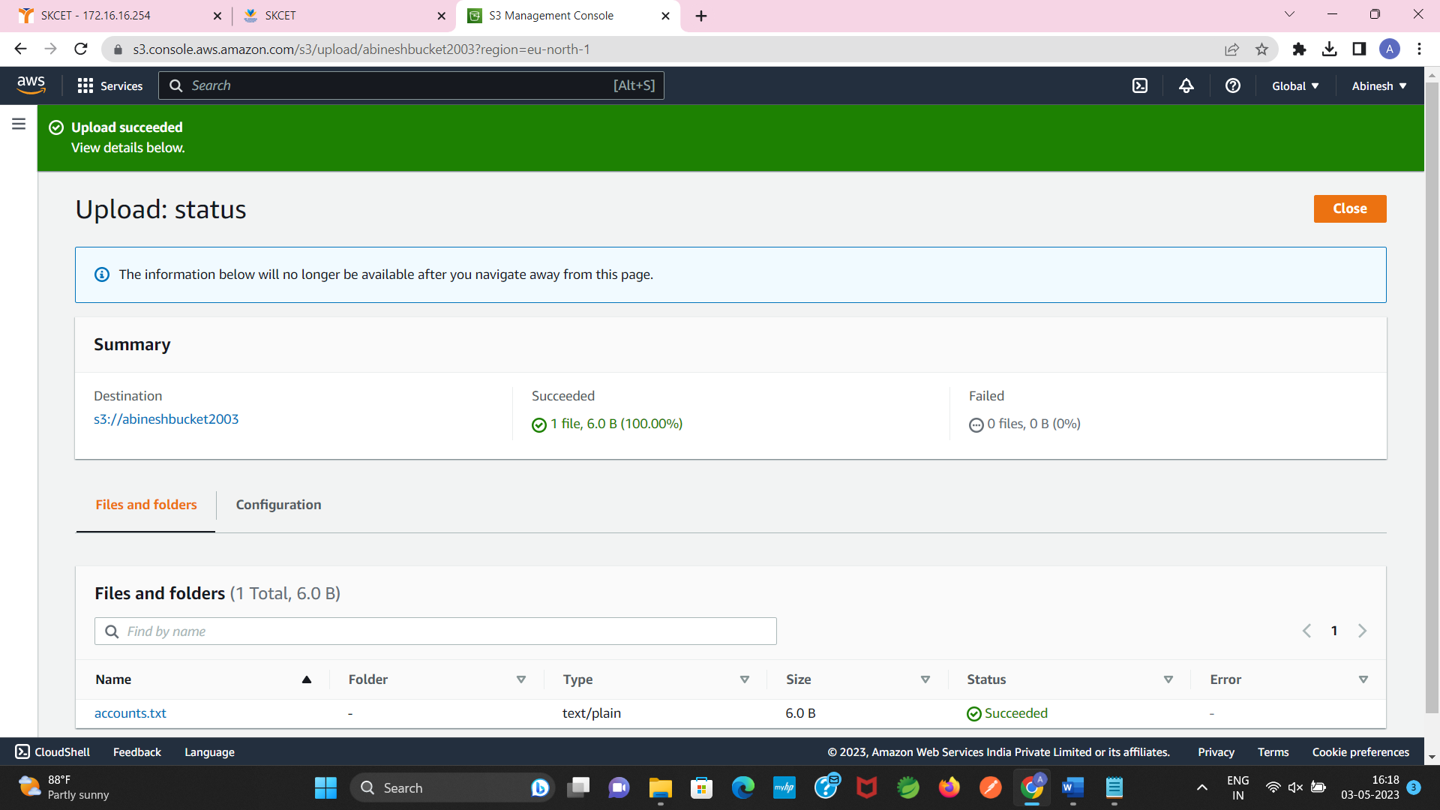

Make the object ‘account.txt’ file accessible to everyone(publicly)

